
Motion Sensors and the Concept of P'sik Reishei
By Rabbi Joshua Flug
For technical information regarding use of this document, press ctrl and click here.

- Intro- As we become more technologically advanced, more and more questions arise regarding Shabbos. Many of the questions center on the concept of p'sik reishei and how we relate to devices that are triggered unintentionally. In this shiur outline, we will present the concept of p'sik reishei with a specific focus on triggering motion sensors.
- Davar She'aino Miskavein and P'sik Reishei
  - The Gemara records a dispute between R. Shimon and R. Yehuda regarding davar she'aino miskavein, an inherently permissible action that produces an unintended prohibited result. We follow the opinion of R. Shimon that davar she'aino miskavein is permissible. {1}
  - The Gemara states that although davar she'aino miskavein is permissible, if the unintended result is unavoidable, it is prohibited. This is called p'sik reishei. Furthermore, it is clear from the Gemara that p'sik reishei is biblically prohibited. {2}
  - The Gemara distinguishes between a result that is beneficial to the one performing the action and a result that is inconsequential to him. This is called p'sik reishei d'lo nicha lei. There is a dispute among the Rishonim regarding p'sik reishei d'lo nicha lei:
    - R. Nassan ben Yechiel (Aruch c. 1035-1106) writes that p'sik reishei d'lo nicha lei is permissible. {3}
      - One can question Aruch's opinion from the prototypical case of p'sik reishei. While the Gemara doesn't state what the case is, ostensibly, the case is where one decapitates an animal (or bird) in order use the head and is not interested in the death of the animal. The rhetorical response to this is p'sik reishei v'lo yamus? The problem is that according to Aruch, p'sik reishei d'lo nicha lei is permissible. Shouldn't the case of decapitating an animal be considered lo nicha lei? Of what consequence is it that the animal dies or remains alive?
      - Perhaps one can answer that this is why Aruch describes the case as dealing with a person (he calls the decapitator a rotzei'ach). Aruch writes that nobody is that cruel to decapitate another person unless he specifically wants that person dead. Therefore, with a person it is always considered nicha lei.
      - Rashi writes that the case deals with decapitating a bird. {4}
      - Rambam writes that we are dealing with an animal. {5}
    - Tosafos write that it is prohibited, albeit m'd'rabanan. The reason why it is only a rabbinic prohibition is that every p'sik reishei d'lo nicha lei will constitute a melacha she'aina tzricha l'gufa. {6}
    - R. Akiva Eger (1761-1837) {7} and R. Elchanan Wasserman (1874-1941) {8} provide the following analysis of the dispute between Aruch and Tosafos:
      - Aruch is of the opinion that the reason why p'sik reishei is normally prohibited is that when it is a p'sik reishei, one can no longer call it aino miskavein. When you know that there is a secondary result, you also intend for that secondary result to happen. However, when it is lo nicha lei, you have no intent for the secondary result to happen and therefore it is permissible.
      - Tosafos are of the opinion that the reason why p'sik reishei is prohibited is that when there is an automatic secondary result, it is part and parcel of the action. Therefore, whether you intend for it to happen or not, it is prohibited. The only reason why lo nicha lei is rabbinic is that it is considered a melacha she'aina tzricha l'gufa.
    - Shulchan Aruch rules in accordance with the opinion of Tosafos.
      - An interesting note on this: In 1934, there was a discussion in America regarding the use of refrigerators on Shabbos. R. Moshe Soloveitchik (1879-1941) sent a letter to R. Simcha Zelig Riger (1864-1942) for his opinion. R. Simcha Zelig wrote back that his father, R. Chaim Soloveitchik was of the opinion that Rambam is also of the same opinion as the Aruch (this idea appears in R. Chaim's sefer in Hilchos Shegagos). Therefore, one may rely on the opinion of the Aruch. {10} [Click here to access the letter. At the end of the letter, R. Simcha Zelig sends regards to the Rav.]
- Leniencies Relating to P'sik Reishei
  - When the result is d'rabanan
    - R. Yisrael Isserlin (1390-1460) writes that when the p'sik reishei only produces a rabbinic prohibition (had it been done intentionally), it is permissible. {11}
    - R. Avraham Gombiner (c. 1633-1683) disagrees and prohibits p'sik reishei even when the result is d'rabanan. {12}
    - Mishna Berurah notes that many Acharonim side with Magen Avraham. {13}
    - R. Yitzchak Elchanan Spektor (1817-1896) writes that one may rely on the opinion of Terumas HaDeshen. {14}
  - When the result is d'rabanan and it is lo nicha lei
    - Tosafos suggest that p'sik reishei d'lo nicha is permissible when the result is d'rabanan. {6}
    - Mishna Berurah (1838-1933) presents two cases where he ostensibly permits psik reishei d'lo nicha lei only when it is a double d'rabanan:
      - Commenting on the psak of Rama (1520-1572) that one may not close a box that has a bug inside because it is a psik reishei of tzeidah {15}, Mishna Berurah notes that if the box is large it is permissible because trapping something in a way that it still can't be caught easily is only d'rabanan and trapping bugs that are not normally trapped is only d'rabanan. Therefore, it is permissible because it is a double d'rabanan on a p'sik reishei. {16}
      - Commenting on Rama's psak that one may not break a cookie with letters written on it {17}, Mishna Berurah writes that one may eat the cookie even if one is going to break the letters with one's teeth because this form of mochek is only shelo al menas lichtov which is d'rabanan and derech achila is a shinui. Therefore, it is a psik reishei on a double d'rabanan. {18}
    - R. Ovadia Yosef writes that one may be lenient when the result is d'rabanan. {19}
    - R. Mordechai Willig writes (based on the previously mentioned rulings of Mishna Berurah) that when the issur d'rabanan is only d'rabanan because of the klalei hamelachos (meleches machsheves), two d'rabanan's are required. When the d'rabanan is not based on klalei melachos, only one d'rabanan is required. {20}
  - Safek p'sik reishei
    - R. Dovid HaLevi Segal (Taz c. 1586-1667) discusses a case where there is a box and one is not sure if there are bugs in the box. If one closes the box and there are bugs in the box, he will certainly trap the bugs. However, if there are no bugs in the box, he will certainly not trap the bugs. He contends that since there is a doubt regarding the result, it is not considered a psik reisha. {21}
    - R. Akiva Eger (1761-1837) notes that Rama seems to disagree. Rama writes that one should not stoke the coals of a fire if there is a pot on the fire that is owned by a non-Jew because there might be basar b'chalav in the pot and by stoking the coals, one is cooking basar b'chalav. {22} R. Akiva Eger notes that ostensibly, one should call this a davar she'aino miskavein because there is no way to know whether the pot contains basar b'chalav. Yet, Rama seems to distinguish between the classic case of davar she'aino miskavein where there is no way to know what will happen and this case where one doesn't know what did happen. R. Akiva Eger notes that Taz disagrees and doesn't distinguish, rather considers both cases to be davar she'aino miskavein. {23}
    - Mishna Berurah discusses the dispute and rules that one may be lenient in cases where the result is d'rabanan. {24}
    - R. Dovid Tzvi Hoffman (1843-1921) suggests that there is no dispute between Rama and Taz. In general, one should distinguish between a doubt that relates to the future and a doubt that relates to the past. However, when it comes to Shabbos, there is another principle of m'leches machsheves which requires a higher standard. Therefore, even if there is a doubt regarding the past, one may be lenient. Rama was dealing with basar b'chalav and was therefore stringent. Taz was dealing with Shabbos and was therefore lenient. {25}
  - Rashba's leniency
    - The Yerushalmi states that if a deer walked into a house and someone closes the door for the normal purpose of closing the door, it is permissible even though he traps the deer. {26}
    - Rashba (1235-1310) understands the Yerushalmi to mean that it is muttar l'chatchilah to do this. {27}
    - Ran (1320-1380) disagrees vehemently with Rashba because this is a classic case of p'sik reishei. The Yerushalmi doesn't mean that you can do this l'chatchilah, rather that b'dieved, if it was done, there is no need to open the door to allow the deer to leave. {28}
    - R. Avraham Borenstein (1838-1910) defends Rashba's position: {29}
      - Trapping an animal by closing the door of a room that the animal voluntarily entered should be considered gerama even if the door was closed with the intent of trapping the deer.
      - The only reason why this is considered tzad is that meleches machsheves can sometimes transform something which is considered gerama into a melacha. (i.e. the melacha of tzad has a built in clause that one can accomplish the melacha even without touching the animal).
      - The concept of meleches machsheves is only employed because one's intent if fulfilled.
      - In the case of closing the door for some other reason, the primary intent is not to trap the animal and therefore, one cannot employ meleches machsheves.
      - Rashba's leniency is not a leniency in the area of p'sik reishei but rather in the melacha of tzad. You cannot violate tzad without touching the animal unless your primary intent is to trap the animal.
  - Shiltei Gibborim's Leniency
    - R. Yehoshua Boaz ben Shimon Baruch (d. 1557) presents another leniency that's very important in contemporary times: {30}
    - He writes that if there is an action that can be performed without the prohibited result, one can perform that action, even if the action in this specific instance will certainly produce the prohibited result.
    - This idea seems to be rooted in a comment of Rashi. Rashi writes that pouring wine on the mizbei'ach is considered a davar she'aino miskavein (in light of the prohibition against extinguishing the flame of the mizbei'ach) because one can pour the wine in very small quantities and avoid extinguishing any flames. Therefore, even if one pours in large quantities, it is not considered a p'sik reisha. {31} [See Rashi Kesubos 5b, who presents a similar idea regarding dam besulim.]
    - R. Tzvi Kushelevski explains that Rashi and Shiltei HaGibborim are of the opinion that p'sik reishei is only prohibited because when there is a prohibited result, one can define the entire action as a prohibited action. Therefore, if the result is not a natural result of that action, one cannot define the action as a prohibited action, even if the specific action will certainly produce a prohibition this time. {32}
- Practical Applications to Motion Sensors
  - What type of device is the motion sensor triggering?
    - If the motion sensor triggers a lightbulb, we are dealing with a potential biblical prohibition.
    - If the motion sensor triggers an LED light or an alarm, etc., we are dealing with a rabbinic prohibition (unless one follows the Chazon Ish).
  - Is the result beneficial?
    - R. Shlomo Zalman Auerbach (1910-1995)- When gauging whether something is nicha lei or lo nicha lei, one must exclude the Shabbos factor. You can't claim that the result is lo nicha lei simply because if it's nicha lei it would create problems on Shabbos. You have to ask whether this result is nicha on a weekday. {33}
    - As a general rule, secondary results are meant to benefit the owner of the device. One exception might be security devices. The owner does not benefit when he personally triggers the sensor. He only benefits when an intruder triggers the sensor.
    - A sensor that provides light for the street may be considered nicha lei depending on how much light there is in the street at the time.
    - If the result is lo nicha lei and rabbinic in nature, there are poskim who are lenient.
  - Does the sensor always get triggered?
    - In many situations of sensors, walking around the sensor may help, but the exact area that is safe is not always known. If this is something that one cannot determine, it is not a p'sik reishei, but rather a davar she'aino miskavein. If it is determinable, but not by the person that is walking by right now, it might be considered a safek p'sik reishei.
    - A similar argument can be made regarding a street where someone knows that there are motion sensors, but he doesn't know which houses have sensors. This ostensibly is a safek p'sik reishei.
  - Applying Rashba's leniency
    - R. Zalman Nechemiah Goldberg applies Rashba's leniency to walking in front of a surveillance camera. {34}
    - He notes that simply walking in front of a camera is inherently gerama.
    - Based on the explanation of Rashba's opinion, one can explain that if someone stands in front of a camera with the intent of being photographed, it is considered meleches machsheves and prohibited. However, if one has no intent of being on the camera, there is no meleches machsheves and it reverts back to gerama and it permissible according to Rashba. Although we don't follow Rashba, we can use this idea as a mitigating factor.
  - Applying Shiltei HaGibborim's leniency
    - R. Tzvi Kushelevski writes that according to Shiltei HaGibborim, one can only classify something as p'sik reishei when the action is defined by the result. {35}
    - Therefore, when someone is walking by a sensor, his actions are not defined as triggering the sensor, but as walking.

- ביצה כג:
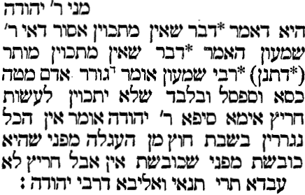
- שבת קג.
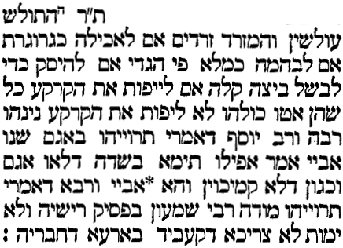
- ערוך ערך פסק
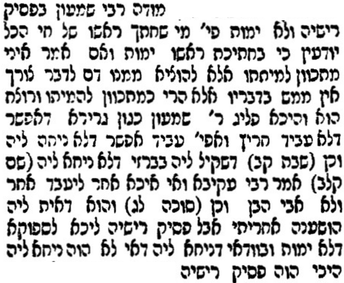
- רש"י סוכה לג:
באומר אחתוך ראש בהמה זו בשבת ואיני רוצה שתמות דכיון דא"א שלא תמות כמתכוין חשיב ליה וכי אמרינן דבר שאין מתכוין מותר כגון היכא דאפשר ליה בלא איסור כגון גורר אדם מטה כסא וספסל ובלבד שלא יתכוין לעשות חריץ ואע"ג דאיכא למיחש דלמא עביד חריץ כיון דלא מתכוין להכי ואפשר לגרירה בלא חריץ כי עביד נמי חריץ דהוי מלאכה גמורה לא מחייב אבל היכא דודאי עביד מודי.
- רמב"ם הל' שבת א:ו
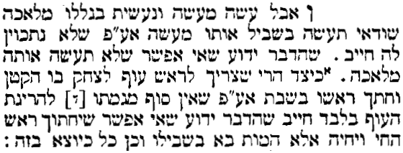
- תוס' שבת קג.
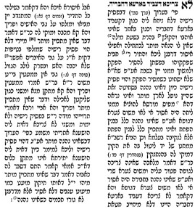
- דרוש וחדוש מערכה י'
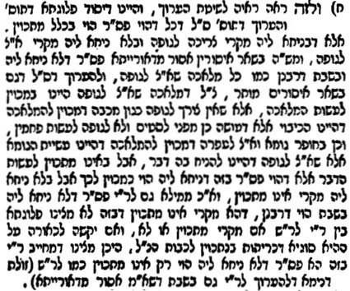

- קובץ שעורים כתגובות אות יח
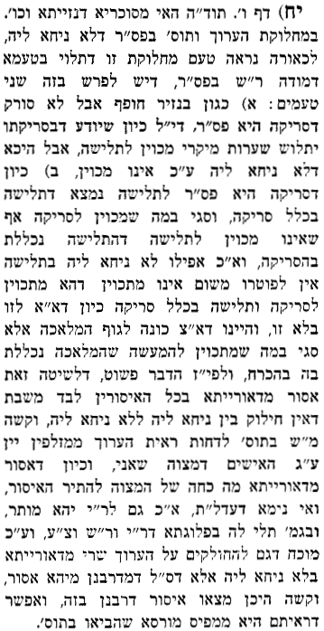
- שלחן ערוך או"ח שכ:יח
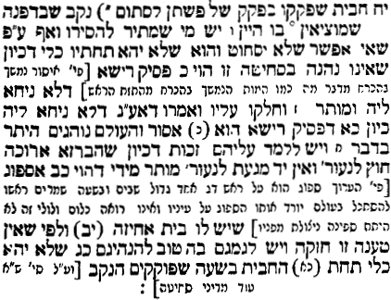
- מאמר הרב שמחה זליג ריגר בהפרדס ח:ג
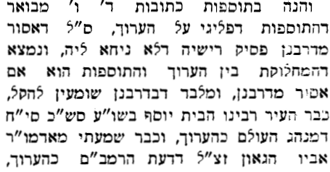
- תרומת הדשן א:סד
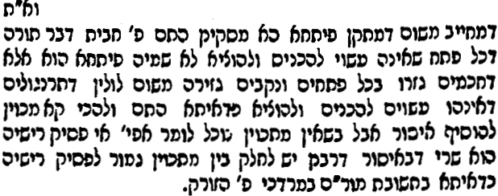
- מגן אברהם שיד:ה
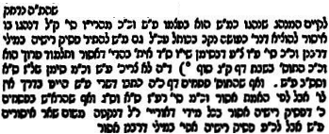
- משנה ברורה שיד:יא
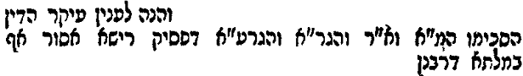
- שו"ת באר יצחק או"ח ס' טו
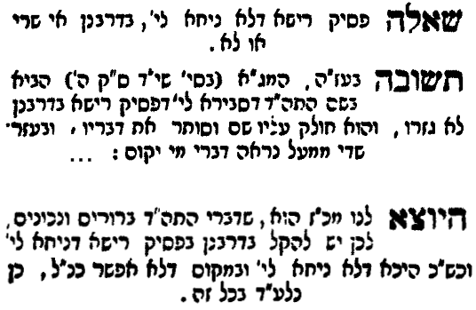
- רמ"א או"ח שטז:ג
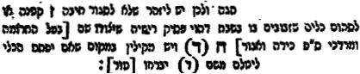
- משנה ברורה שטז:טו
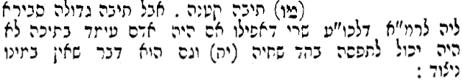
- רמ"א או"ח שמ:ג
- משנה ברורה שמ:יז
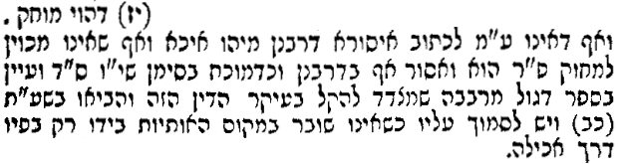
- יחוה דעת ב:מו
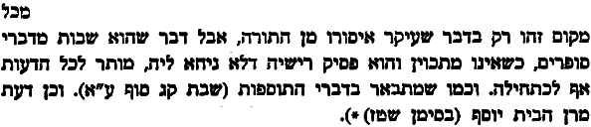
- עם מרדכי שבת ס' לא
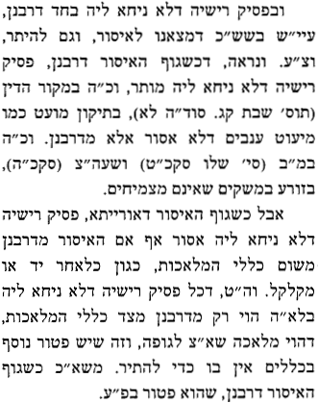
- ט"ז או"ח שטז:ג
נר' דה"ק חדא דאפי' אם בודאי יש זבובים לא קרוי ניצוד כמו דבורים ועוד אפי' אם תאמר דבודאי הוה פ"ר ואסור מ"מ בספק אם יש שם זבובים יש להתיר דשם אין פ"ר כי זה הוה ספק פ"ר והוה דבר שלא במתכוין ומותר כמו בכור' היכא דלא הוה פ"ר כגון שיש נקב קטן כמש"ל ה"נ אין פסיק רישיה בודאי כי אפשר שאין שם זבובים וזה היא כמו במקום דלא הוי פ"ר דמותר שלא במתכוין.
- רמ"א יו"ד פז:ו
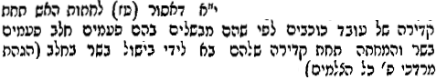
- גליון רבי עקיבא איגר יו"ד ס' פז
קשה לי הא אינו מכוין לבשל רק לחתות באש ופסיק רישא לא הוי דשמא לא בישל העובד בהקדירה בשר וגם חלב וצ"ל דדוקא בספק דלהבא שמא יהא נעשה כן במעשה שלו כמו גורר כסא וספסל דהוי ספק שמא בגרירתו לא יעשה גומא אבל בספק דעבד כמו הכא דאם יש בקדירה בלוע בשר וחלב בחיתוי זה בודאי יתבשל אלא דהספק שמא אין בו בליעת בשר וחלב זה מקרי פסיק רישא ... אבל לדעת הט"ז א"ח שכתב שם לדעת הטור בנועל התיבה וספק אם יש זבובים דמותר לנועלו דהוי דבר שאינו מתכוין ואף דהוי פ"ר מ"מ דלמא אין שם זבובים ולא הוי פ"ר א"כ לכאורה בנ"ד היתר גמור דהא אינו מתכוין לבשל כלי של עובד כוכבים ואפשר דאין בתוכו כלל בלוע בב"ח לא הוי פ"ר.
- ביאור הלכה שטז:ג
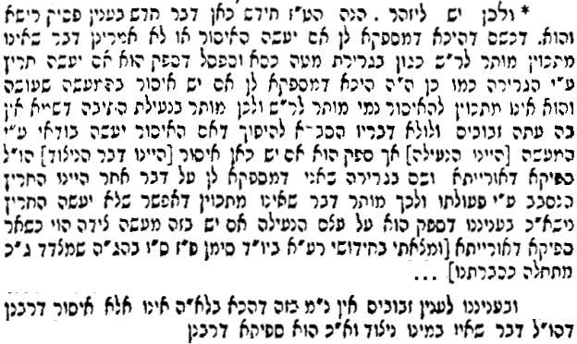
- שו"ת מלמד להועיל ג:קב
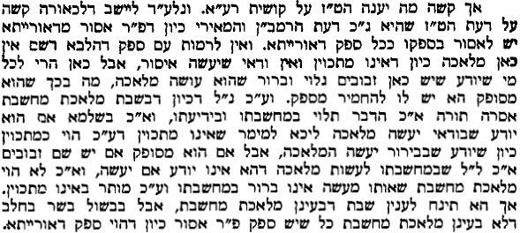
- תלמוד ירושלמי יג:ו
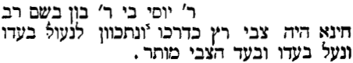
- רשב"א שבת קז.
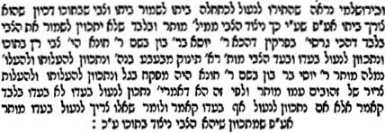
- ר"ן שבת לח.
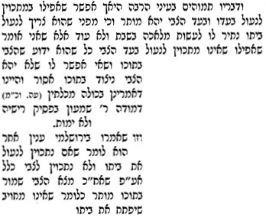
- שו"ת אבני נזר או"ח ס' קצד
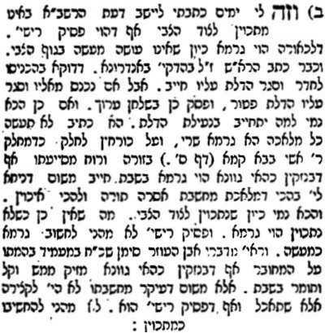

- שלטי הגיבורים שבת לח. אות א'
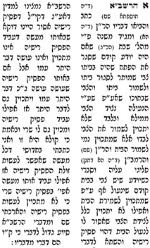
- רש"י זבחים צא:
ואם תאמר פסיק רישא ולא ימות הוא אפשר דמזליף ליה בטיפין דקות מאד הלכך אי נמי מכבה בטיפים גסות דבר שאין מתכוין הוא.
- מאמר הרב צבי קושלבסקי עטרת שלמה חוברת ט'
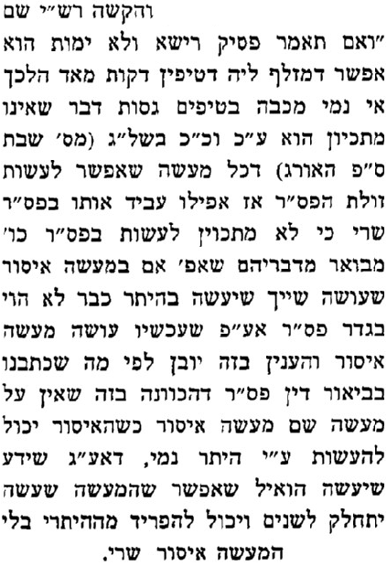
- מנחת שלמה א:צא:ט
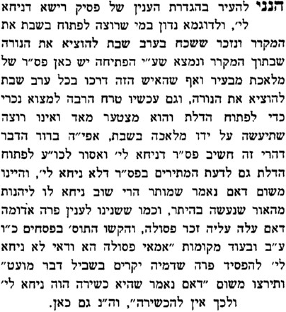

- מאמר הרב זלמן נחמיה גולדברג עטרת שלמה ו'
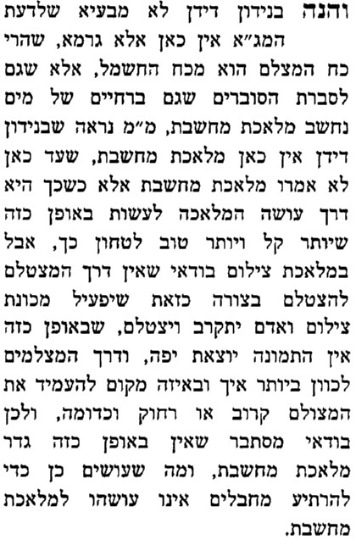
- מאמר הרב צבי קושלבסקי עטרת שלמה חוברת ט'
